**File to IDOC Scenario**

**Pre- requisite to start this development-**

**Integration Repository** - Software Components defined for Sender and Receiver System.

**Integration Directory** – Business System for ECC sender needs to be defined.

**Business Logic behind this development**

Sender file system will load the file to PI.

PI will perform the basic transformation/mapping.

The result of mapping needs to be send to the Receiver ECC as IDOC.

**Design**

1. **Access to the Process Integration Tools**

Link provided

<http://in-mum-solman:50000/dir/start/index.jsp>

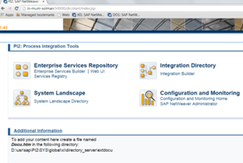

**2. Access Enterprise Service Repository(ESR)**

Click on the link Enterprise Service Builder under Enterprise Service Repository. The following

screen appears –

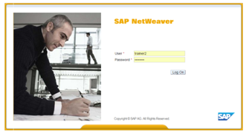

Login to PI using your user id and password.

**3. Import the software component define in SLD**

Import the following software component defined for the scenario into ESR

CAPGEMINI_TRAINER_MASTER, 1.0 of capgemini

Click on new under object and select SWCV under Work Areas

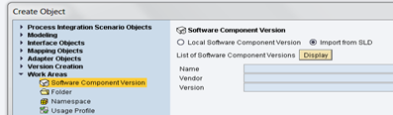

Click on Display and select the required sender and receiver business system to be imported into ESR for further development

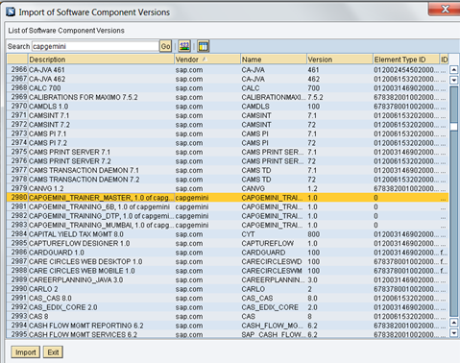

**4. Define Namespace**

You Define a Namespace for you SWCV that uniquely identifies all the objects you create in Repository.

Right click software component version and select Namespace from the context.

Create the following namespace

urn:sampleFile_IDOC_<<**last three digit of employee ID>>**

After creating and saving it appears like –

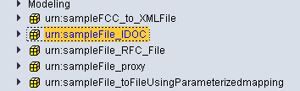

**5. Import IDoc**

**Note :** For Scenarios involving Idoc on sender/receiver , no need to define Data Type, Message

type and service Interface. Just need to import the IDoc for ECC server and use it in place of

message type and service interface.

Import the required IDoc into ESR under the software component defined for ECC system as

below –



Select the **correct** Idoc required and continue as under –



Once the Idoc is successfully imported, activate the same and it appear as below in ESR-

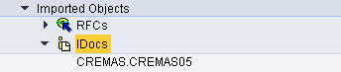

**6. Define Data Type**

1. Date type(DT_File_Sender_<Name/EmpNo> for Sender System (FileSystemA)

2. Date type(DT_File_Receiver_< Name/EmpNo >) for Receiver System (FileSystemB)

Create data types with required structure and type of elements as shown below.

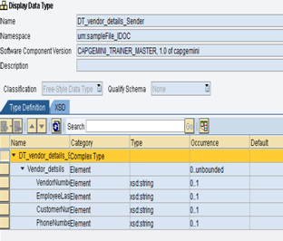

**7. Define Message Type**

1. Message type(MT_File_Sender_<Name/EmpNo> for Sender System (FileSystemA).

2. Message type(MT_File_ Receiver_< Name/EmpNo >) for Receiver System (FileSystemB)

Select the Data type (created in the previous step)for the message type. The Namespace automatically gets populated. This is the message type for sender system. Save after completing.

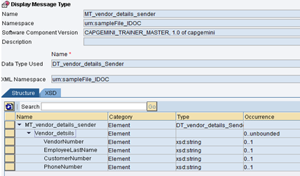

**8. Create Service Interfaces**

1. Service Interface(SI_File_Sender_Out_< Name/EmpNo> ) for Sender System (FileSystemA).

2. Service Interface(SI_File_Receiver_In_< Name/EmpNo> ) for Sender System (FileSystemB).

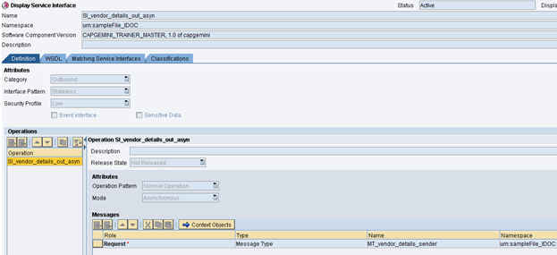

This is the service interface for the sender system. Save after completing

**9. Create the Message Mapping**

Create a new Message mapping MM_Idoc_FileA_<Name/EmpNo>

The mapping in this scenario is one-to-one. The names of the source field and target fields are identical. To perform a mapping, drag the source fields and drop on the target field. The mapping would be displayed in the graphical display.

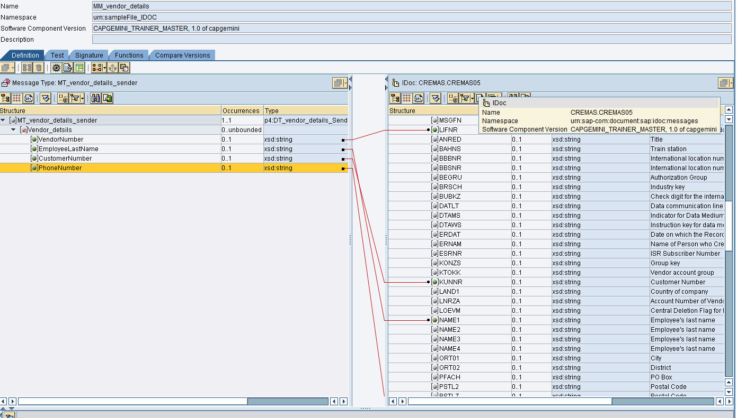

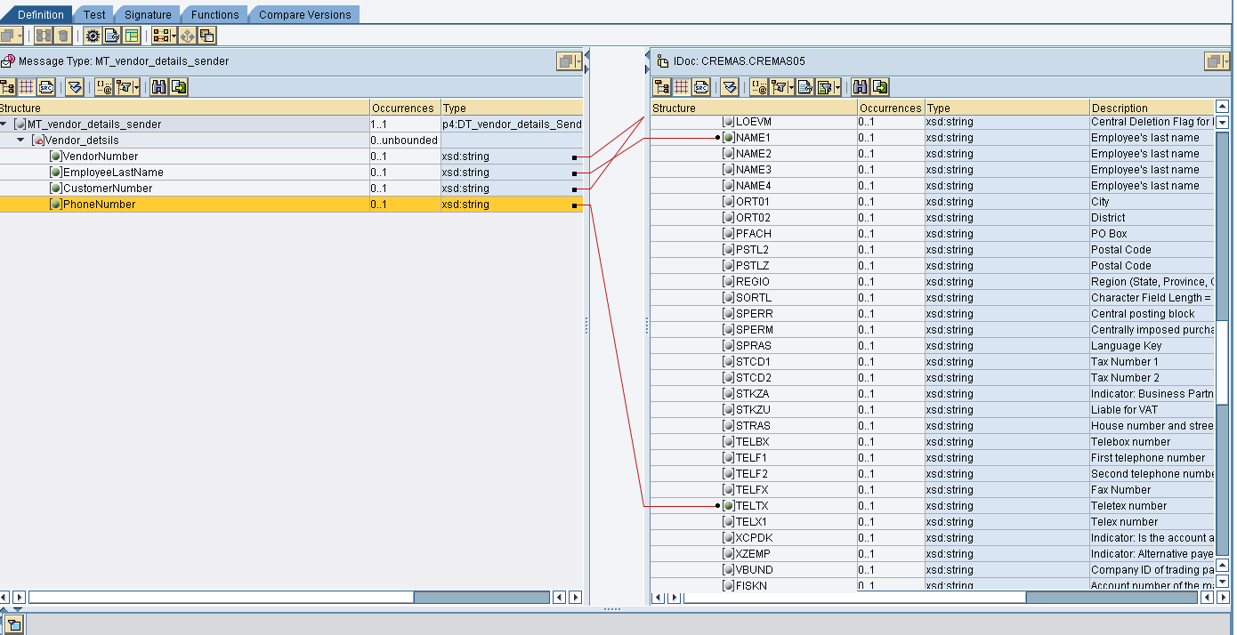

You can test you mapping by going to test Tab. You can select either of the two buttons from

the tool bar to test your scenario.

1. Load XM Instance – load an XML file that contains your test data.

2. Generate Instance – By specifying the value manually.

Now you can test the scenario by clicking the Execute Mapping.

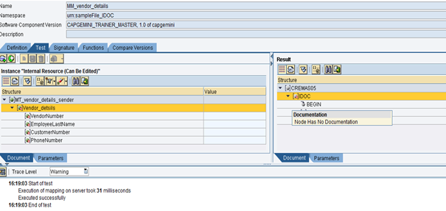

**10. Create the Operation Mapping**

In the operation mapping, Select the source interface as “SI_vendor_details_out_asyn” and target interface as “CREMAS.CREMAS05 ”. Click on the Read Interfaces tab and

source/target message types automatically get populated.

Select the message mapping as “MM_Idoc_FileA_<Name/EmpNo> “

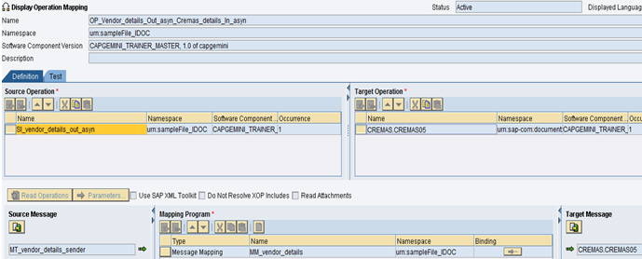

**Configuration**

1. **Access to the Process Integration Tools**

Link provided.

<http://in-mum-solman:50000/dir/start/index.jsp>

1. **Access Integration Directory**

Click on the link Integration Builder under Integration Directory. The following screen appears –

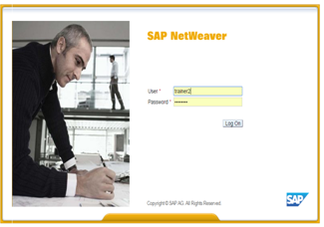

Login to PI using your user id and password.

**3. Create a new Scenario**

Scenario is a place holder for the configuration of interfaces. A scenario can hold the

configuration for multiple interfaces.

Create a Configuration Scenario CS_sampleFile_IDOC as shown below

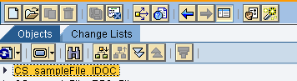

**4. Create Business Component for Sending and receiving File system**

Assign the Service Interfaces to Business Component as shown below

**FOR SENDER COMPONENT**

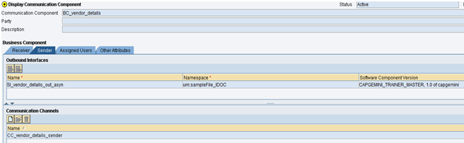

**FOR RECEIVER COMPONENT**

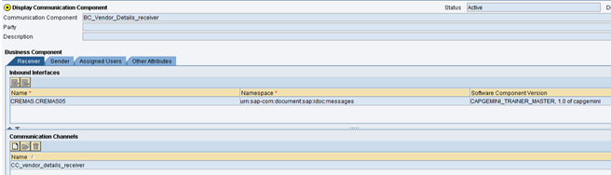

**6. Create Communication Channels**

**Note**: Configurations for PI ABAP stack for **SM59**, **IDX1** and **IDX2** is already in place. Please make sure that you use example the same RFC destination and port given in the receiver IDOC adapter channel in this document.

Please reuse the IDOC channel and also reuse the sender business component of this sample for your interface.

This communication channel will enable the business component/business system and

Integration server to communicate to each other.

**Sender Communication Channel –**

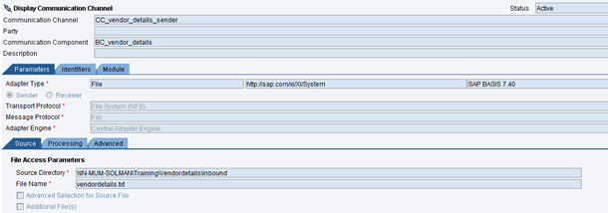

**Receiver Communication Channel –**

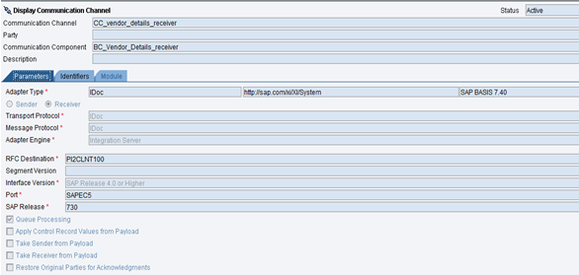

**7. Receiver Determination**

A receiver determination defines one or more receivers for a sender and a outbound Service

interface. Create a new receiver determination, by right the scenario and then select Receiver

Determination under Configuration Objects

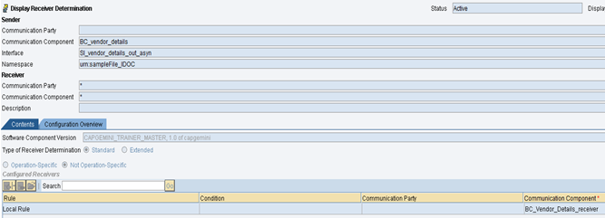

**8. Interface Determination**

In this step, we need to determine the inbound service interface using which the receiver

system is expected to receive data.

Create a new interface determination, by right the scenario and then select Interface

Determination under Configuration Objects , as shown below

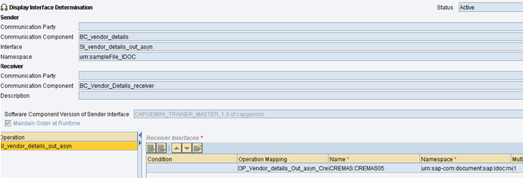

**9. Sender and Receiver Agreement**

The agreements we need to specify the communication channel to be used by sending/receiving systems to actually connect to Integration Engine.

Create the sender and receiver receiver agreement by specifying sender and receiver business

component and adding corresponding communication channel.

**SENDER AGREEMENT**

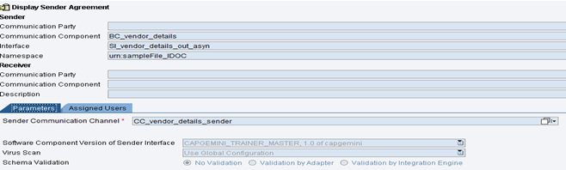

**RECEIVER AGREEMENT**

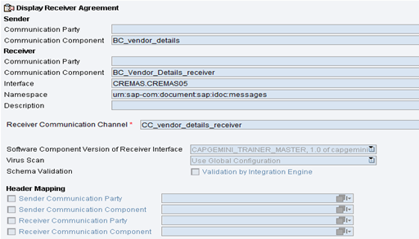

**TESTING**

Please use the below attached file for testing. Once you have processed the file check your IDOC in WE05 of EC5 client 100.

